GDPR and HIPAA
Tasks
1.
Create a comparison table listing at least 3 key differences between GDPR and HIPAA, focusing on how each standard impacts cloud data storage for apps like Zomato or Paytm.
2.
Log in to the AWS Management Console and find the AWS Artifact service; download any sample compliance report (such as SOC 2 or ISO 27001) and write 2 lines about what type of compliance information it provides.
3.
In Azure Portal, locate and list 3 built-in compliance features or tools (such as Azure Policy, Compliance Manager, or Security Center) that help companies meet standards like GDPR or HIPAA.<br><br><em><strong>Hint:</strong> Use the search bar in the portal to quickly find these services.</em>
4.
Pick a familiar app (like Instagram, Flipkart, or PhonePe) and describe one scenario where using a cloud provider’s compliance feature (from AWS or Azure) would help protect user data and meet legal requirements.

Answer : Task 1 — GDPR vs HIPAA comparison
First, understand the basic difference:
- GDPR → Protects personal data of people in the European Economic Area and applies broadly to many types of personal information.
- HIPAA → U.S. healthcare privacy/security law covering protected health information (PHI) handled by covered entities and business associates.
For apps such as Zomato or Paytm, GDPR can be relevant if they process data of people in the GDPR's territorial scope. HIPAA generally matters only if the app/provider is handling PHI in a HIPAA-covered context.
Key difference | GDPR | HIPAA
Main purpose | Protects personal data and privacy of individuals. | Protects health information and regulates its use/disclosure.
Type of data | Broad: names, emails, location, IDs, online identifiers, etc. | Mainly Protected Health Information (PHI), such as medical and patient information.
Cloud storage impact | Companies need appropriate security, access controls, data protection measures, and rules for international data transfers. | Organizations handling PHI need appropriate administrative, physical, and technical safeguards.
Example with Paytm/Zomato | Customer account, contact, location or transaction-related personal data may require privacy protections depending on applicability. | Normal food-order/payment data isn't automatically HIPAA data; HIPAA becomes relevant if PHI is involved in a covered arrangement.
Cloud provider responsibility | The organization remains responsible for meeting its legal obligations; cloud providers can provide security/privacy controls and contractual mechanisms. | A cloud provider handling PHI for a covered entity/business associate may need to meet HIPAA-related requirements and enter appropriate agreements.
Easy way to remember:
👉 GDPR = general personal privacy
👉 HIPAA = health/medical information

Task 2 — AWS Artifact
AWS Artifact is an AWS service where customers can access AWS security and compliance documents, including ISO certifications and SOC reports. AAmazon Web Services, Inc.+1

Step 1: Open AWS
Go to the AWS Management Console and sign in.

Step 2: Find Artifact
After logging in:
- Look at the AWS Console search bar at the top.
- Type Artifact.
- Select AWS Artifact.
- You should reach the Artifact Home page.
AWS's own instructions say Artifact can be found under Security, Identity & Compliance. AAmazon Web Services, Inc.

Step 3: Open reports
Look for:
View Reports → AWS Reports
You can search for reports using keywords such as:
- SOC
- ISO 27001

Step 4: Download
- Select a report.
- Click Download report.
- If AWS asks you to accept terms, read them and select the agreement checkbox.
- Click Accept terms and download.
That's the normal AWS Artifact process. AAmazon Web Services, Inc.

What to write about the report
You can write:
AWS Artifact compliance reports provide evidence about AWS's security and compliance controls and independent assessments/certifications. For example, SOC and ISO reports provide information that organizations can use when evaluating AWS for their own compliance requirements.
Small note: Artifact reports are AWS compliance evidence; downloading one does not automatically make your own application GDPR/HIPAA compliant.

Task 3 — Azure Portal compliance features
Now open the Azure Portal and sign in.
Use the search bar at the top as your hint suggests.
Here are three good features to use:

1. Azure Policy
How to find it:
- Sign in to Azure Portal.
- Use the top search bar.
- Search Azure Policy.
- Open it.
What it does:
Azure Policy allows organizations to define and enforce rules for their cloud resources. It can check whether resources follow required configurations and compliance policies. Microsoft identifies Azure Policy as Azure's primary governance tool. MMicrosoft Learn+1
Simple example:
You could create policies requiring certain security configurations for storage resources.

2. Microsoft Purview Compliance Manager
Search the Azure/Microsoft portal for:
Compliance Manager
Compliance Manager helps organizations assess and manage compliance using assessments, controls, improvement actions and compliance scores. MMicrosoft Learn
It can help organizations understand what they need to do to align with regulations and standards.

3. Microsoft Defender for Cloud
Search:
Defender for Cloud
Then look for:
Regulatory compliance
Defender for Cloud continuously assesses cloud resources against selected compliance standards and identifies compliance issues and recommendations. MMicrosoft Learn+1
It can monitor standards and show which controls are compliant or non-compliant.

Short answer for your assignment
Azure feature | Purpose
Azure Policy | Enforces rules and checks whether Azure resources follow required configurations.
Microsoft Purview Compliance Manager | Helps assess compliance, track controls, and manage improvement actions.
Microsoft Defender for Cloud | Continuously checks cloud resources against security and regulatory standards and provides recommendations.

Task 4 — Example using PhonePe
Let's use PhonePe because it's easy to understand.
Scenario
Imagine PhonePe stores customer information such as account details and transaction-related data in Azure.
The company could use Azure Policy to enforce security requirements for its cloud resources.
For example, PhonePe could create policies requiring appropriate security configurations for storage resources. If a resource doesn't satisfy a required policy, the organization can identify and correct the problem.
Azure Policy and Defender for Cloud can be used together: Azure Policy provides governance rules, while Defender for Cloud can continuously assess resources and provide compliance/security recommendations. MMicrosoft Learn+1

Simple assignment wording
Scenario: PhonePe stores sensitive customer and transaction data in the cloud. Using Azure Policy, PhonePe can enforce security requirements for its cloud resources and reduce the risk of incorrectly configured storage. This helps the company maintain stronger protection of user data and support its compliance obligations.

📝 What you should actually do
For your practical work, follow this order:
Task 1
- Copy/create the GDPR vs HIPAA comparison table.
- Add 3–5 differences.
Task 2 — AWS
- Log in to AWS.
- Search Artifact.
- Open AWS Artifact.
- Select View Reports.
- Find a SOC or ISO report.
- Download it.
- Write 2 lines explaining what compliance information it provides.
Task 3 — Azure
- Log in to Azure Portal.
- Search Azure Policy.
- Search Compliance Manager.
- Search Defender for Cloud.
- Write one or two lines about each.
Task 4
- Choose PhonePe/Instagram/Flipkart.
- Explain what user data is being protected.
- Name one AWS/Azure compliance feature.
- Explain how that feature helps protect the data and support legal compliance.
Useful official guides: AWS provides an Artifact walkthrough for accessing and downloading compliance reports. AWS Artifact Getting Started Microsoft also documents how Defender for Cloud's regulatory compliance dashboard assesses resources and identifies gaps. Microsoft Defender for Cloud — Regulatory Compliance

1. GDPR vs HIPAA — easy examples
Think of it this way:
Situation | GDPR | HIPAA
Zomato stores your name, phone number and location | ✅ Could be personal data covered by GDPR | ❌ Normally not HIPAA
Paytm stores your email and account information | ✅ Could be covered by GDPR | ❌ Normally not HIPAA
A healthcare app stores your medical records | ✅ May apply if GDPR's scope applies | ✅ HIPAA may apply if the app/provider is covered
Cloud database contains patient medical information | Requires appropriate privacy/security measures if GDPR applies | Requires HIPAA safeguards where HIPAA applies

Very simple example
GDPR example:
A food-delivery app stores:
Name → Rahul
Phone → 98XXXXXX
Location → Mumbai
The company needs appropriate controls for personal data, such as access control, security and applicable data-transfer protections.
HIPAA example:
A healthcare application stores:
Patient → Rahul
Diagnosis → Diabetes
Medical report → X-ray
This is the kind of health information that can fall under HIPAA when handled in a HIPAA-covered context.

2. AWS Artifact — what it looks like
When you search AWS Artifact, you'll eventually reach the reports area.
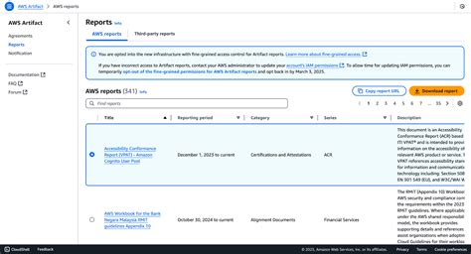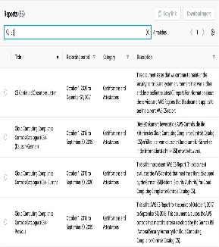
The screenshot above shows an example of the AWS Artifact Reports page. You can see things such as:
- Report title
- Reporting period
- Category
- Search box
- Compliance documents
AWS says Artifact provides reports such as SOC, ISO and PCI documents. AAWS Docs+1

What you should click
AWS Console → Search "Artifact" → AWS Artifact → View reports → AWS reports
Then search for:
SOC 2
or
ISO 27001
AWS's documentation confirms that reports can be searched and downloaded from the Artifact console. AAWS Docs

Example of what you can write
Example: I accessed AWS Artifact and viewed the available compliance reports. A SOC 2/ISO report provides information about AWS security controls and independent assessment/certification evidence that can be used by customers and auditors.

3. Azure — three features
You can search these names in the Azure Portal search bar.
🔵 A. Azure Policy
Example: Imagine PhonePe stores customer data in Azure.
Azure Policy can be used to establish rules such as:
"Storage resources must follow our required security configuration."
Azure Policy has a compliance dashboard that lets organizations see which resources comply with policies and which don't. MMicrosoft Learn
Easy assignment line:
Azure Policy helps organizations enforce security and governance rules and check whether cloud resources comply with required policies.

🟢 B. Microsoft Purview Compliance Manager
Search in the portal:
Compliance Manager
Think of this as a compliance checklist/dashboard.
For example:
Requirement: Protect customer information
↓
Control: Use appropriate security measures
↓
Assessment: Is the organization following the control?
↓
Action: Fix anything that is missing.
Microsoft says Compliance Manager can integrate with Defender for Cloud and support regulatory/industry standards. MMicrosoft Learn

🟠 C. Microsoft Defender for Cloud
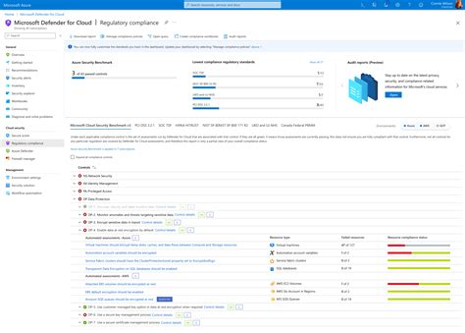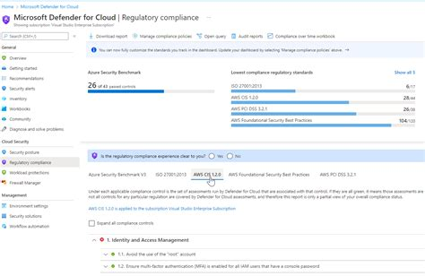
Search:
Defender for Cloud
Then look for:
Regulatory compliance
You can see compliance standards and controls, with compliant/non-compliant resources.
Microsoft explains that Defender for Cloud continuously assesses applicable resources against security standards and identifies compliance issues. MMicrosoft Learn
Easy assignment line:
Microsoft Defender for Cloud monitors cloud resources against security and regulatory standards and identifies areas that need improvement.

4. One complete example — PhonePe
Here's a very easy scenario you can use.

📱 Situation
Imagine PhonePe stores customer information in Azure.
For example:
Customer name
Mobile number
Transaction information
Account-related information

☁️ Problem
Suppose an administrator accidentally creates a cloud storage resource with an insecure configuration.
That could increase the risk of unauthorized access.

🛡️ Solution
PhonePe could use Azure Policy to define and monitor required security configurations.
The organization can then see whether resources are compliant and take corrective action when they aren't. MMicrosoft Learn

Simple diagram
PHONEPE APP
│
▼
┌───────────────────┐
│ Azure Cloud │
│ │
│ Customer Data │
│ Transactions │
│ Account Data │
└─────────┬─────────┘
│
▼
┌───────────────┐
│ Azure Policy │
└───────┬───────┘
│
Checks security rules
│
┌────┴────┐
▼ ▼
COMPLIANT NON-COMPLIANT
│ │
│ ▼
│ Fix the problem
▼
Better protection
of user data

⭐ One sentence to remember
Azure Policy = "Check whether my cloud resources follow my organization's rules."
Defender for Cloud = "Find security/compliance problems and show me how to improve them."
Compliance Manager = "Help me organize and track my compliance work."

📸 What screenshots to take for your assignment
You don't need dozens of screenshots. I'd take 4 screenshots:
- AWS Artifact → Reports page
Shows that you found Artifact and its compliance reports.
- AWS Artifact → selected SOC/ISO report
Shows the report you selected/downloaded.
- Azure → Azure Policy
Shows that you found the service.
- Azure → Defender for Cloud → Regulatory compliance
Shows the compliance dashboard/standards.
These will give you good practical evidence that you actually explored the AWS and Azure portals.

